CEREMONY SCRIPT EXAMPLE

Narrator : Protocol Candidate
Presiding Officer (PO) :
Official Party :

(Narrator announces :)

GOOD EVENING LADIES AND GENTLEMEN, PLEASE WELCOME THE BRITISH ARMY PIPE BAND – 4 SCOTS PIPES AND DRUMS.

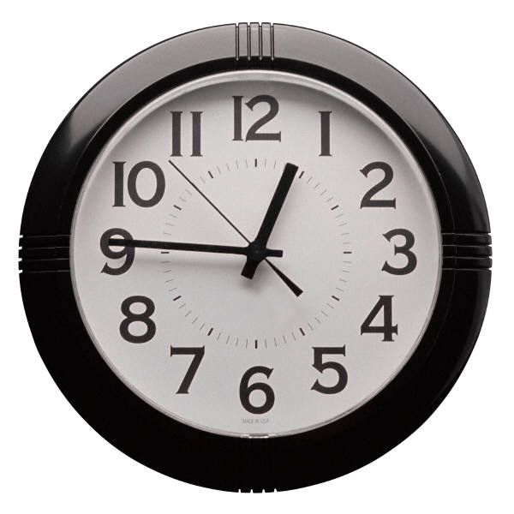 + 5 seconds (Narrator announces :)

LADIES AND GENTLEMEN. AS WE PREPARE TO

OBSERVE THE 69th NORFOLK NATO

FESTIVAL FLAG RAISING CEREMONY WE ASK THAT

YOU PLEASE TAKE YOUR VIEWING POSITIONS AND

SILENCE ALL ELECTRONIC DEVICES AT THIS TIME.

THROUGHOUT TODAY’S EVENT YOU WILL BE GIVEN

CUES TO STAND AND BE SEATED AT THE

APPROPRIATE TIMES. THE CEREMONY WILL BEGIN IN

5 MINUTES.

+ 5 seconds (Narrator announces :)

ONCE AGAIN, GOOD EVENING LADIES AND

GENTLEMEN. WE ARE HONOURED BY YOUR

PRESENCE AS WE OBSERVE THE 69th ANNUAL

NORFOLK NATO FESTIVAL FLAG RAISING CEREMONY.

+ 5 seconds (Narrator announces :)

UNDER THE DIRECTION OF SENIOR CHIEF MUSICIAN AND DRUM MAJOR, THE UNITED STATES FLEET FORCES BAND WILL MARCH ON THE COLOUR GUARD AND THE FLAG BEARERS OF ALL 30 NATO MEMBERS NATIONS.

FLAG BEARERS ATTENTION

LADIES AND GENTLEMEN, PLEASE RISE.”

FLAG BEARERS, LEFT FACE

+ 5 seconds (Narrator announces :)

THE NORTH ATLANTIC TREATY ORGANIZATION, KNOWN AS NATO, IS AN INTERNATIONAL POLITICAL AND MILITARY ORGANIZATION CREATED 73 YEARS AGO WITH THE AIM OF PROTECTING ITS 30 CURRENT MEMBER NATIONS.
NATO HAS TWO COMMANDS BASED IN NORTH AMERICA, HEADQUARTERS, SUPREME ALLIED COMMAND TRANSFORMATION AND JOINT FORCE COMMAND – NORFOLK, BOTH LOCATED ON NAVAL SUPPORT ACTIVITY HAMPTON ROADS.
EACH YEAR HEADQUARTERS, SUPREME ALLIED COMMANDER TRANSFORMATION LEADERSHIP SELECTS THE MOST OUTSTANDING STAFF MEMBERS TO BE RECOGNIZED AS THE MEMBERS OF THE YEAR.
WITHOUT FURTHER ADO, WE ARE PLEASED TO WELCOME:

- THE OUTSTANDING NATO CIVILIAN OF THE YEAR

** (PAUSE) **

- THE JUNIOR MILITARY MEMBER OF THE YEAR

** (PAUSE) **

- THE SENIOR MILITARY MEMBER OF THE YEAR

** (PAUSE) **

- THE JUNIOR MILITARY OFFICER OF THE YEAR

** (PAUSE) **

PLEASE JOIN US WITH A ROUND OF APPLAUSE TO RECOGNIZE THEIR INVALUABLE CONTRIBUTIONS.

+ 5 seconds (Narrator announces :)

AT THIS TIME WE ARE PLEASED TO WELCOME OUR

OFFICIAL PARTY:

- CHAIRMAN OF THE NORFOLK NATO FESTIVAL.

** (PAUSE) **

- COMMANDING GENERAL, FLEET MARINE FORCE, ATLANTIC;
AND COMMANDER, MARINE FORCES COMMAND;
AND MARINE FORCES NORTHERN COMMAND.
** (PAUSE) **

- DEPUTY SUPREME ALLIED COMMANDER TRANSFORMATION.
** (PAUSE) **

- THE HONOURABLE MAYOR OF THE CITY OF NORFOLK
** (PAUSE) **

- SUPREME ALLIED COMMANDER TRANSFORMATION

FLAG BEARERS, PARADE REST.

GUESTS, PLEASE BE SEATED.

+ 5 seconds (Narrator announces :)

WE WILL NOW RECOGNIZE NATO AND EACH OF THE THIRTY MEMBER NATIONS THAT FORM THE ALLIANCE.

FLAG BEARERS ATTENTION

+ 5 seconds (Narrator announces :)

AS A REMINDER, DURING THE PLAYING OF

THE NATIONAL ANTHEM, MILITARY

MEMBERS SHOULD STAND AT ATTENTION AND

RENDER SALUTE ON THE FIRST NOTE.

+ 5 seconds (Narrator announces :)

THE NATIONAL ANTHEM OF THE UNITED STATES OF AMERICA.

+ 5 seconds (Narrator announces :)

THE NATO HYMN.

** (PAUSE) **

FLAG BEARERS, PARADE REST

+ 5 seconds (Narrator announces :)

LADIES AND GENTLEMEN, THE NORFOLK NATO

FESTIVAL CHAIRMAN, WILL NOW MAKE AN ADDRESS.

+ 5 seconds (Narrator announces :)

LADIES AND GENTLEMEN THE HONOURABLE

MAYOR OF THE CITY OF NORFOLK, WILL NOW MAKE

AN ADDRESS.

+ 5 seconds (Narrator announces :)

THE HONOURABLE MAYOR OF THE CITY OF NORFOLK

WILL NOW PRESENT THE NORFOLK MACE TO

SUPREME ALLIED COMMAND TRANSFORMATION.

THE NORFOLK MACE ORIGINALLY CAME TO

NORFOLK IN 1754 AS THE SYMBOL OF KING GEORGE’S

ROYAL POWER, AS VESTED IN THE GOVERNOR .

THIS MAGNIFICENT SILVER MACE IS THE

ONLY ONE STILL BOTH INTACT AND IN THE CITY TO

WHICH IT WAS FIRST PRESENTED. HAVING SURVIVED

THE WAR OF INDEPENDENCE WHERE IT WAS BURIED

IN A FIELD, AND THE CIVIL WAR WHERE IT WAS

HIDDEN IN A FIREPLACE, IT IS A SYMBOL OF

THE RESILIENCE AND SURVIVAL OF NORFOLK.”

+ 5 seconds (Narrator announces :)

LADIES AND GENTLEMEN, SUPREME ALLIED

COMMANDER TRANSFORMATION, WILL NOW MAKE

AN ADDRESS.

+ 5 seconds (Narrator announces :)

LADIES AND GENTLEMEN PLEASE RISE.

THE UNITED STATES FLEET FORCES BAND WILL

NOW HONOUR THE MILITARY SERVICE OF ALL

ALLIANCE NATIONS, BY PLAYING THE U.S. MILITARY

SERVICE SONGS, FOLLOWED BY THE OFFICIAL PASS

IN REVIEW OF ALL NATO MEMBER NATIONS LED BY

THE COLOR GUARD.

+ 5 seconds (Narrator announces :)

PLEASE REMAIN STANDING FOR THE DEPARTURE OF THE OFFICIAL PARTY.

+ 5 seconds (Narrator announces :)

THIS CONCLUDES OUR FLAG RAISING CEREMONY.

PLEASE FEEL FREE TO STAY AND OBSERVE BAND OF THE NETHERLANDS MOUNTED ARMS REGIMENT AS THEY PLAY FOR YOUR ENJOYMENT. THANK YOU ALL FOR ATTENDING.

